LAB 4:
Round robin:

#include <stdio.h>
struct Process {
int id, at, bt, rt, ct, tat, wt;
} p[10];
int main() {
int n, tq, time = 0, completed = 0;
int queue[100], front = 0, rear = 0;
int visited[10] = {0};
float total_wt = 0, total_tat = 0;

int gantt_p[200], gantt_t[200], k = 0;
printf("Enter number of processes: ");
scanf("%d", &n);
for (int i = 0; i < n; i++) {
p[i].id = i + 1;
printf("Enter AT and BT for P%d: ", i + 1);
scanf("%d %d", &p[i].at, &p[i].bt);
p[i].rt = p[i].bt;
}
printf("Enter Time Quantum: ");
scanf("%d", &tq);
gantt_t[k] = time;
for (int i = 0; i < n; i++) {
if (p[i].at <= time) {
queue[rear++] = i;
visited[i] = 1;
}
}

while (completed < n) {

if (front == rear) {
time++;
for (int i = 0; i < n; i++) {
if (p[i].at <= time && !visited[i]) {
queue[rear++] = i;
visited[i] = 1;
}
}
continue;
}

int i = queue[front++];

gantt_p[k] = p[i].id;

if (p[i].rt > tq) {
time += tq;
p[i].rt -= tq;
}
else {
time += p[i].rt;
p[i].rt = 0;
p[i].ct = time;
p[i].tat = p[i].ct - p[i].at;
p[i].wt = p[i].tat - p[i].bt;
total_tat += p[i].tat;
total_wt += p[i].wt;

completed++;
}
gantt_t[++k] = time;
for (int j = 0; j < n; j++) {
if (p[j].at <= time && !visited[j]) {
queue[rear++] = j;
visited[j] = 1;
}
}
if (p[i].rt > 0) {
queue[rear++] = i;
}
}
printf("\nID\tAT\tBT\tCT\tTAT\tWT\n");
for (int i = 0; i < n; i++)
printf("%d\t%d\t%d\t%d\t%d\t%d\n",
p[i].id, p[i].at, p[i].bt, p[i].ct, p[i].tat, p[i].wt);
printf("\nAverage Turnaround Time = %.2f", total_tat / n);
printf("\nAverage Waiting Time = %.2f\n", total_wt / n);
printf("\nGantt Chart:\n|");
for (int i = 0; i < k; i++)
printf(" P%d |", gantt_p[i]);
printf("\n%d", gantt_t[0]);
for (int i = 1; i <= k; i++)
printf(" %d", gantt_t[i]);
printf("\n");
return 0;
}

Output: 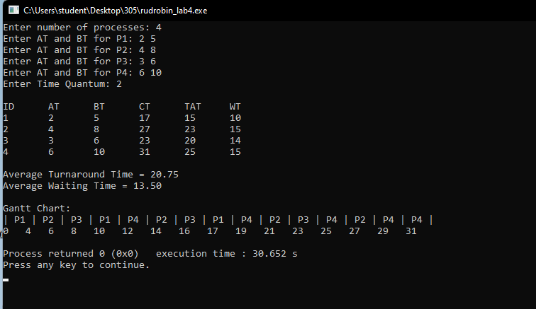

2. Multilevel Scheduling:

#include <stdio.h>
struct Process {
int id, at, bt, type, ct, tat, wt;
} p[20], temp;

int main() {
int n, time = 0;
float total_wt = 0, total_tat = 0;
printf("Enter number of processes: ");
scanf("%d", &n);
for (int i = 0; i < n; i++) {
p[i].id = i + 1;
printf("P%d - AT, BT, Type (0-Sys, 1-User): ", i + 1);
scanf("%d %d %d", &p[i].at, &p[i].bt, &p[i].type); }
for (int i = 0; i < n - 1; i++) {
for (int j = 0; j < n - i - 1; j++) {
if (p[j].type > p[j+1].type ||
(p[j].type == p[j+1].type && p[j].at > p[j+1].at)) {
temp = p[j];
p[j] = p[j+1];
p[j+1] = temp;
}
}
}
for (int i = 0; i < n; i++) {
if (time < p[i].at)
time = p[i].at;
time += p[i].bt;
p[i].ct = time;
p[i].tat = p[i].ct - p[i].at;
p[i].wt = p[i].tat - p[i].bt;
total_tat += p[i].tat;
total_wt += p[i].wt;
}
printf("\nType\tID\tAT\tBT\tCT\tTAT\tWT\n");
for (int i = 0; i < n; i++)
printf("%s\t%d\t%d\t%d\t%d\t%d\t%d\n",
(p[i].type == 0 ? "Sys" : "User"),
p[i].id, p[i].at, p[i].bt, p[i].ct, p[i].tat, p[i].wt);
printf("\nAverage Turnaround Time = %.2f", total_tat / n);
printf("\nAverage Waiting Time = %.2f\n", total_wt / n);
return 0;
}

Output:
